Technical Report for Annual Progress Monitoring 2026

PhD Project “Improving Whole-cell Model with Machine Learning/AI”
Contents
Introduction to Research 1
Research Gap and Objectives 2
Methodology and Research Plan 3
Preliminary Work and First Results 4
wcEcoli Analysis 4
vEcoli Analysis 6
Single-cell Simulation Using vEcoli 6
Colony Simulation Using vEcoli 10
Ongoing Work 12
Academic Activities and Outputs 12
References 12

Introduction to Research
Genome-scale metabolic models (GSMMs) describe the full metabolic network of a cell and enable prediction of metabolic fluxes and growth phenotypes under different environmental conditions. Building on this framework, whole-cell models (WCMs) extend genome-scale modelling by integrating metabolic, regulatory, and signalling processes into a unified simulation framework, enabling in-silico investigation of cellular behaviour across the entire cell cycle (Karr et al., 2012; Macklin et al., 2020).
This PhD project aims to explore the use of machine learning techniques to improve the efficiency and applicability of whole-cell models. In particular, the project currently focuses on developing machine learning–based surrogate models that can approximate computationally expensive simulations, enabling larger-scale biological simulations and new types of analysis.
This PhD project commenced in January 2025 and is expected to be completed by January 2029.

Research Gap and Objectives
This project focuses on Escherichia coli, a model organism widely used in systems biology and biotechnology due to its rapid growth, well-characterised physiology, and extensive genetic engineering toolkit (Adamczyk and Reed, 2017). Understanding how genetic perturbations and environmental conditions influence E. coli behaviour at both the single-cell and colony levels is important for studying its cellular processes and genotype–phenotype relationships. Computational models provide a means to investigate these processes systematically, particularly where experimental observation of intracellular dynamics is limited.
The latest colony-scale simulations incorporating embedded metabolic models remain limited in their ability to capture realistic cellular behaviour. Many approaches rely on simplified linear relationships between environmental conditions and cell growth (Tack et al., 2017), while others focus primarily on metabolic changes arising from genotypic variation without fully accounting for dynamic cellular responses (Großkopf et al., 2016; Zomorrodi and Segrè, 2017). Consequently, these approaches provide only partial representations of cellular behaviour in complex colony environments.
Although whole-cell models such as wcEcoli (Macklin et al., 2020) and vEcoli (Skalnik et al., 2023) provide a highly detailed representation of cellular processes, their application at the colony scale is constrained by substantial computational demands. Even with high-performance computing resources (224 CPUs and 896 GB RAM), simulating just over 200 cells requires approximately two days of computation (Skalnik et al., 2023). This computational cost becomes prohibitive when scaling to realistic colony sizes. In contrast, realistic colony simulations often involve tens of millions of cells, rendering direct whole-cell simulation infeasible.
To overcome these computational limitations while preserving the mechanistic richness of whole-cell models, surrogate modelling approaches have been proposed. Existing surrogate modelling approaches partially address this limitation but remain restricted in scope. Current practices (Gherman et al., 2025) typically require full whole-cell model simulations for the initial generation and produce static predictions that do not evolve dynamically over multiple cell cycles. As a result, these surrogates are unable to capture long-term changes in cellular behaviour across successive generations.
At the population level, individual-based and agent-based modelling (ABM) frameworks offer a promising avenue for bridging cellular- and colony-level dynamics by linking mechanistic intracellular knowledge to emergent population-scale behaviour (Hellweger et al., 2016). However, their effectiveness depends critically on the availability of computationally efficient and biologically informed cell-level models.
Therefore, to address these challenges, this project proposes the development of a specialised machine learning–based surrogate model for colony-scale simulation.
The proposed surrogate model aims to:
- Enable dynamic predictions by jointly incorporating genotypic information and culture conditions.
- Significantly reduce computational cost at the prediction stage while allowing more expensive training procedures.
- Produce biologically relevant outputs, specifically cellular growth rate and secretion profiles.
By providing a computationally efficient approximation of whole-cell behaviour, the surrogate framework could enable colony-scale simulations that would otherwise be computationally infeasible. In the longer term, the surrogate framework will support applications such as evolutionary simulations, cross-feeding dynamics, biofilm formation, and antibiotic response studies.

Methodology and Research Plan
To support the development of the proposed surrogate model, relevant methodologies have been investigated through literature review and preliminary experimentation. Several machine learning approaches have been considered for surrogate construction, including linear regression (LR), support vector regression (SVR), Dynamic Mode Decomposition (DMD), and artificial neural networks (ANNs). These methods provide different levels of interpretability and modelling flexibility, and their investigation informs both the selection of modelling approaches and the phased research plan described later in this section.
As an initial step, computationally inexpensive classical machine learning approaches are chosen for surrogate construction. Linear regression will serve as a transparent baseline model for evaluating predictive performance. Support vector regression will also be assessed as an efficient surrogate modelling approach, as demonstrated in previous studies (Angione et al., 2022; Pruett and Hester, 2016).
Dynamic Mode Decomposition (DMD) was also reviewed as a data-driven approach for modelling dynamical systems through coupled spatial–temporal modes. DMD constructs a linear approximation between consecutive system states using singular value decomposition, allowing dominant dynamic patterns to be extracted without explicitly computing the underlying system operator (Jose Nathan Kutz et al., 2017). While DMD has demonstrated strong performance in modelling time-series dynamics, its current applicability to scalar outputs is limited. As the current plan focuses on predicting low-dimensional scalar outputs, it is considered a potential extension for future work.
Artificial Neural Networks (ANNs) are currently identified as the primary modelling framework for the surrogate model. Following a staged complexity strategy, development will begin with simple regression models and multilayer perceptrons before exploring more advanced architectures such as multi-task networks.
In addition, recent studies have shown that a bio-informed architecture can improve efficiency and predictive performance in biomedical applications, predicting a cell’s expression level (Ma et al., 2018) or disease-relevant biomarkers (Meirer et al., 2024). In bio-informed neural networks (BINNs), hidden layers correspond to biologically meaningful quantities such as transcription success, translation success, and expression levels (Selby et al., 2025). This design aims to improve interpretability while maintaining predictive capability, which aligns well with the objectives of this project.
Based on these methodological considerations, the research will follow a three-phase development plan consisting of: (1) growth rate prediction, (2) growth and metabolite exchange prediction, and (3) colony-level integration.
The initial phase focuses on predicting cellular growth rate as a single output. This phase will be used to validate the network architecture and training strategy.
A dataset comprising 463 single-gene knockout simulations will be used for model training and validation. A five-fold cross-validation scheme will be applied to ensure robust performance assessment.
In the second phase, the surrogate model will be extended to jointly predict growth rate and metabolite exchange fluxes, including approximately twenty exchange metabolites. This stage will employ a multi-task learning framework.
In the final phase, the surrogate model will be integrated into a colony simulation framework where it replaces repeated calls to the full vEcoli model. Simulation performance will be evaluated by comparing surrogate-driven colony simulations with reference simulations from the full model.

Preliminary Work and First Results
During the early stage of the PhD, foundational literature on whole-cell models and systems biology was studied through textbooks such as Fundamentals of Systems Biology: From Synthetic Circuits to Whole-cell Models, as well as recent research papers including Whole-cell modelling of E. coli colonies enables quantification of single-cell heterogeneity in antibiotic responses. Knowledge from various sources was integrated into personalised notes and references using academic management tools such as Obsidian and Mendeley.

wcEcoli Analysis
Firstly, I analysed wcEcoli, the most recent implementation of the Escherichia coli whole-cell model. The model is downloaded from public GitHub repository in March 2025 and loaded both locally and on university’s HPC cluster.
To better understand the structure of the model, a directed network representing molecular entities and their interactions across biological processes was constructed by incorporating the interdependencies between submodels of wcEcoli. As shown in Figure 1, nodes represent either a molecular process (such as TF binding or transcription) or a molecular entity (such as genes or metabolites). Edges between nodes are extracted from the wcEcoli code repository, with directionality reflecting the data flow — that is, the inputs and outputs of each submodel.
This representation provides a holistic overview of the relationships between molecular entities and processes within the whole-cell model, from which statistical features of the network can be extracted (Figure 2). For example, edges (221 thousand) substantially outnumber nodes (42 thousand), and translation contributes the greatest number of edges followed by transcription, indicating that the structural complexity of the model is primarily concentrated in the gene expression machinery.

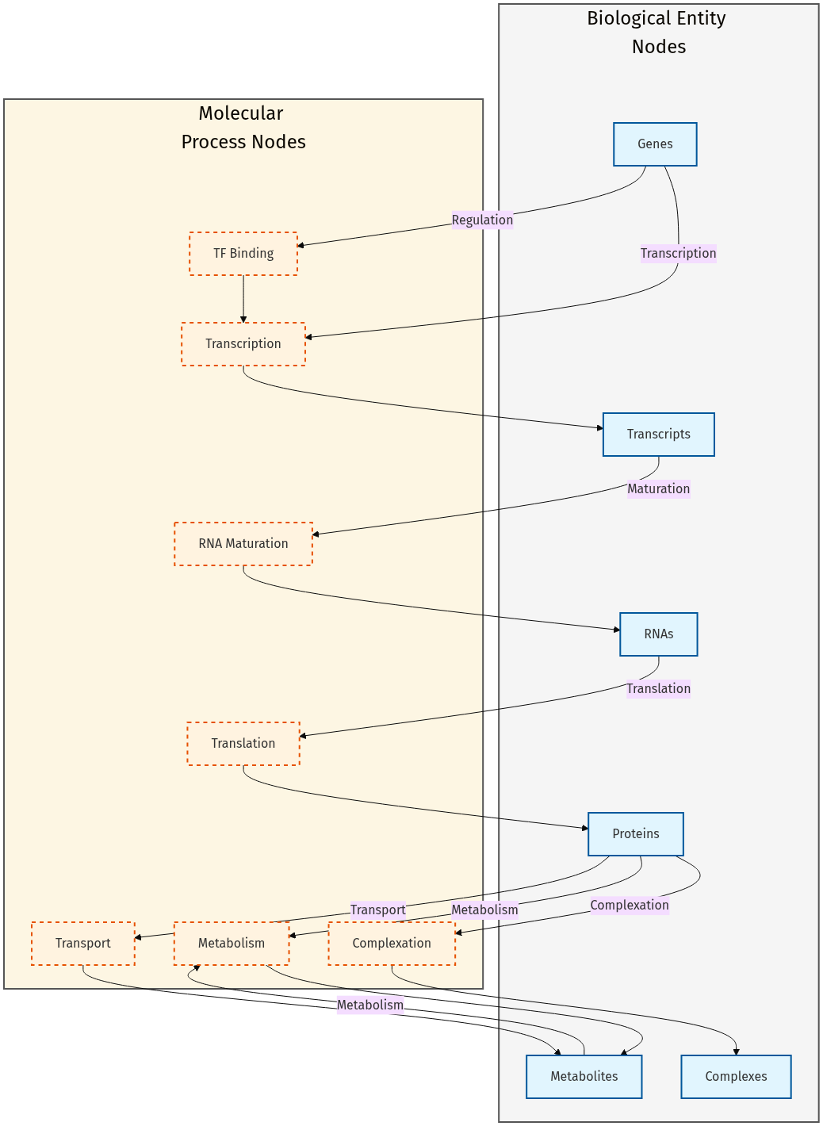
Figure 1: wcEcoli Causality Network Schematic
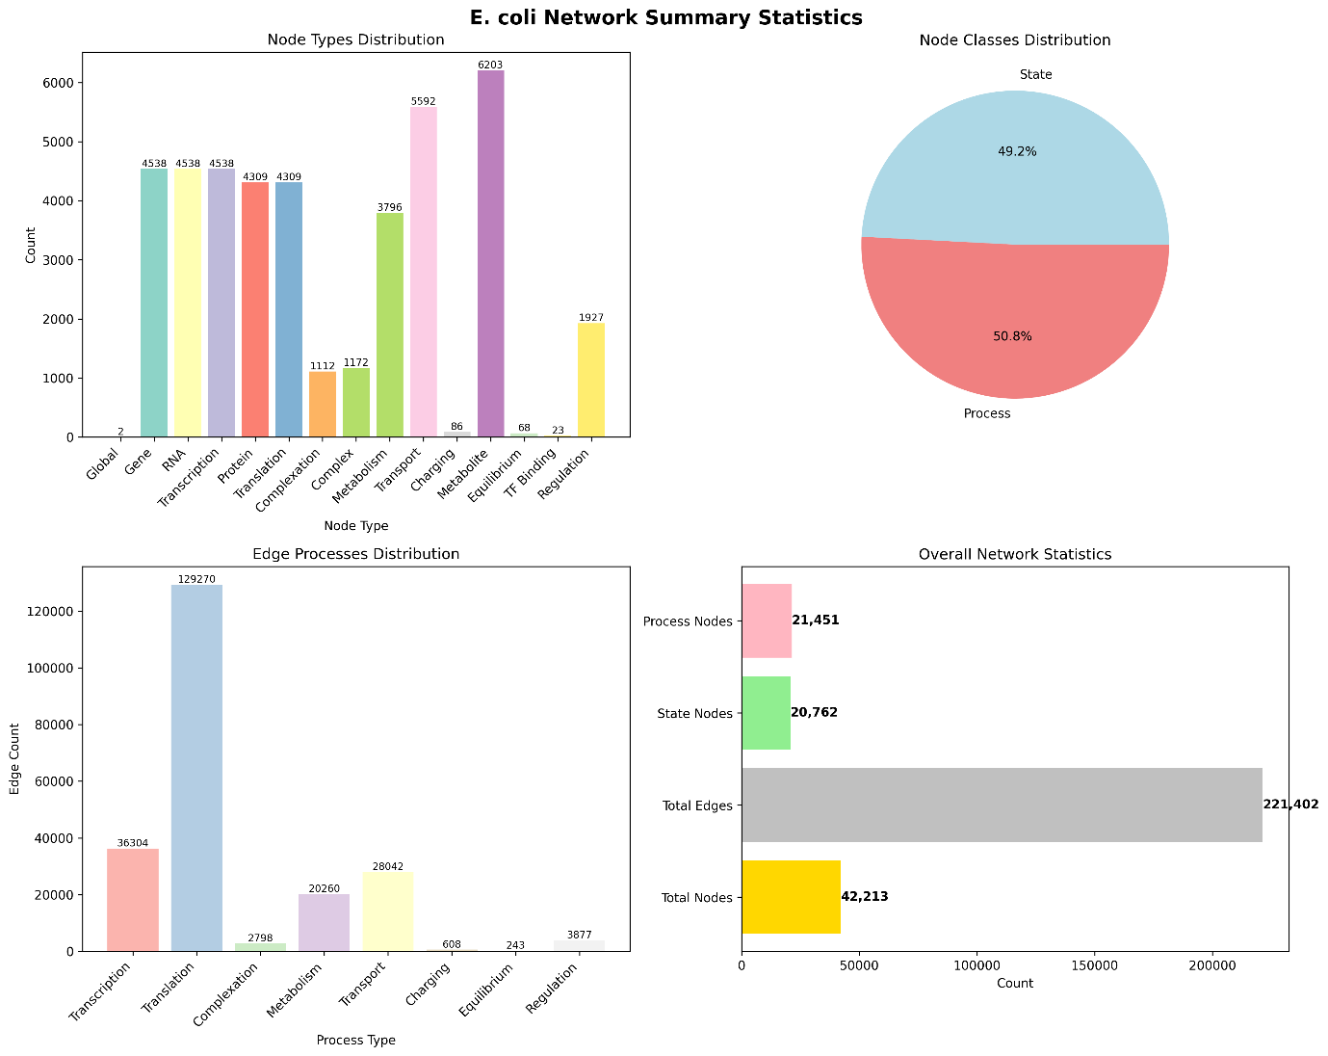
Figure 2: wcEcoli Causality Network Statistical Summary

vEcoli Analysis
To support the planned work on colony-scale surrogate modelling, subsequent efforts shifted to vEcoli, a colony-level simulation framework derived from the wcEcoli model that enables the simulation of interacting cells within a shared environment. The latest version of vEcoli was successfully installed and configured on remote computational environments, i.e., the HPC cluster provided by the school. Trial simulations were conducted to verify the functionality of the modelling framework and explore different simulation configurations.

Single-cell Simulation Using vEcoli
A customised gene knockout function was developed to enable systematic perturbation studies (Algorithm 1). The correctness of this implementation was validated by analysing transcription and translation outcomes in single-gene knockout variants, confirming that the expected molecular effects were achieved during simulation. As shown in Figure 3, the gene-knockout variants have no initiation event in transcription and result in a protein count decline.
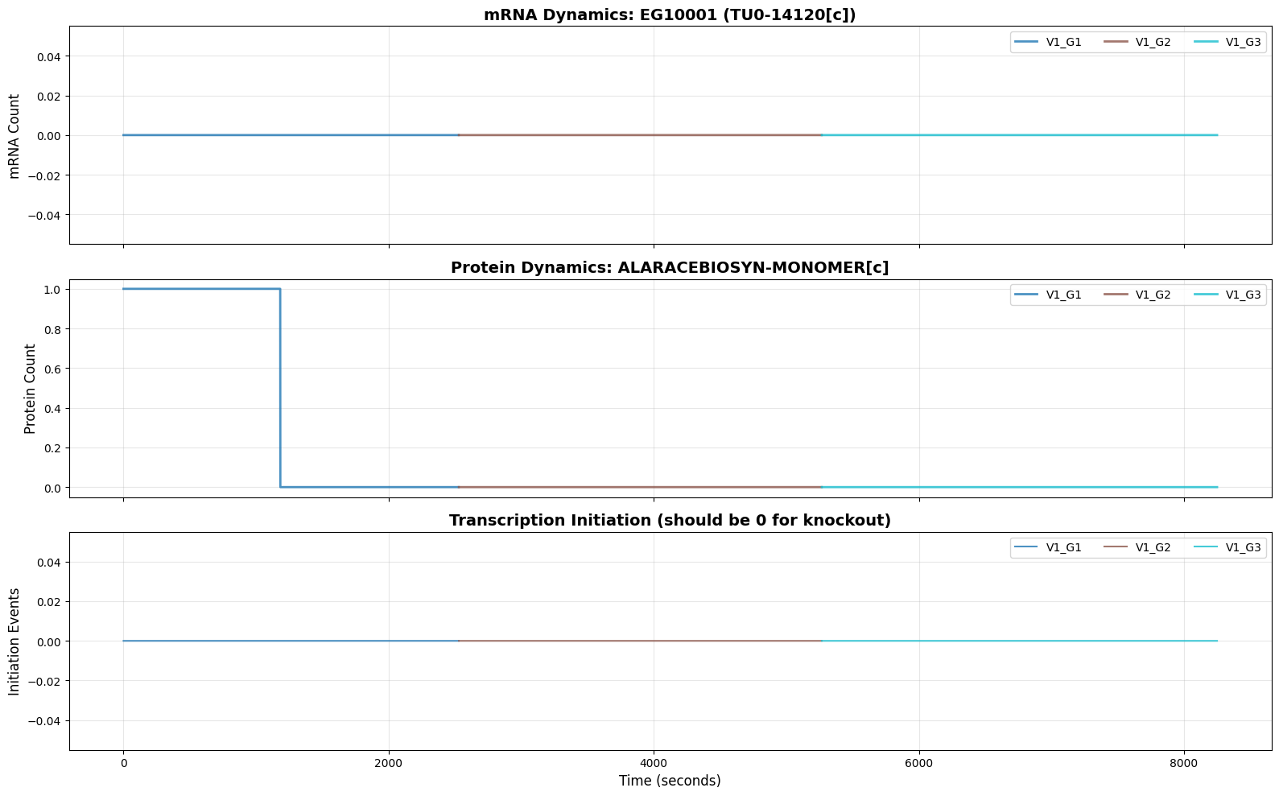
(a)
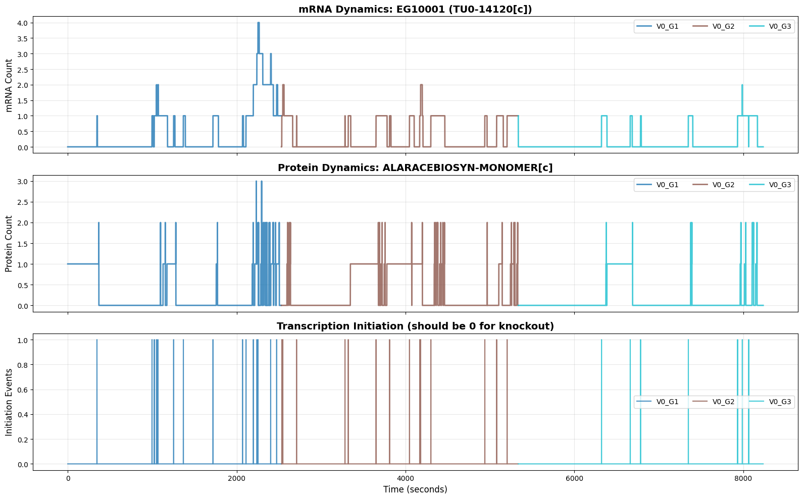
(b)
Figure 3: Comparison of mRNA counts and associated translation and transcription successes for single-cell simulation where EG1001 knockout is performed (a) and without (b).
In the validation trial run of gene-knockouts simulation, all genes available in vEcoli were classified into two categories: metabolic genes and non-metabolic genes. Metabolic genes were defined as those whose translation products directly participate in the metabolic sub-model, while non-metabolic genes do not have direct metabolic involvement.
The preliminary experiments in vEcoli were conducted using a trial dataset consisting of 20 metabolic genes and 20 non-metabolic genes. For each single-gene knockout variant, due to the limitation of computational resources, only single-cell simulations are conducted. Additionally, five different media conditions including “baseline”, “with amino-acid”, “acetate”, “succinate”, and “no oxygen”, are applied to run the simulation with wildtype cell. These media conditions are selected because they are available as model defaults and is derived from experimental data (Appendix 2),
These single-cell simulations were performed across eight generations in baseline media condition, with only one daughter cell tracked across generations.
To explore relationships between model inputs and gene expression processes, an initial correlation analysis was performed.
Mutual information (MI) measures the statistical dependence between two variables by quantifying the reduction in uncertainty of one variable given knowledge of the other (Mackay, 2003). In this work, entropy terms required for MI computation were calculated following Shannon’s information theory, with implementation details provided in Algorithm 2 in Appendix 1.
However, MI values depend on the entropy of the variables and are therefore difficult to compare across datasets. Normalised mutual information (NMI) provides a scale-free, model-free measure of statistical dependency bounded between 0 and 1, where 0 indicates statistical independence and 1 indicates a perfect deterministic relationship (Estévez et al., 2009). Since a machine learning surrogate can only exploit statistical structure present in the data, non-zero NMI between inputs and outputs is a necessary condition for a viable model.
Therefore, NMI was computed between model inputs (including media conditions and gene knockouts), transcription and translation success, and transcription and translation rates for a total of 45 simulations (40 single-gene knockouts and 5 media condition variants).
Furthermore, to investigate the concept of a bio-informed neural network — as explained in Section “Methodology and Research Plan”, a network whose hidden layer structure reflects known biological intermediates rather than arbitrary units — two layers of biologically motivated information are incorporated between the inputs and the growth rate output.
The first hidden layer encodes transcription and translation success rates, while the second encodes the resulting bulk molecule counts (mRNA and protein). Crucially, transcription success maps exclusively to mRNA counts and translation success to protein counts, reflecting the directional dependency of gene expression. The conceptual architecture is shown in Figure 4, where inputs are genetic perturbations and media conditions, and the output is cellular growth rate.
The results shown in Figure 5 reveal several input-output relationships with NMI exceeding 0.1, indicating that meaningful statistical dependency exists between model inputs and gene expression outputs, and providing empirical justification for pursuing a machine learning surrogate.
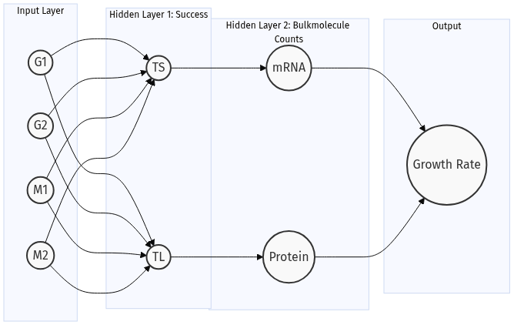
Figure 4: Conceptual architecture of a bio-informed neural network for predicting cellular growth rate. Genotype and media conditions are used as inputs (G1, G2, M1, M2). The first hidden layer represents transcription and translation success (TS, TL), while the second hidden layer represents molecular product counts in single-cell level (mRNAs and proteins). The output node corresponds to the average cellular growth rate across eight generations. The number of nodes shown is illustrative and does not reflect the full dimensionality of the model.
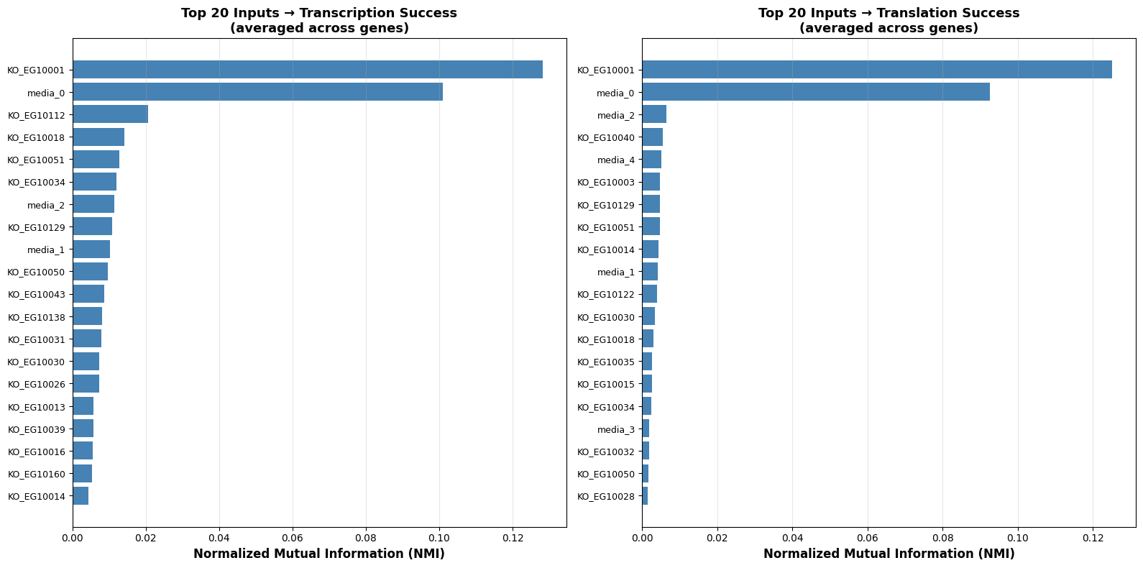
(a) (b)

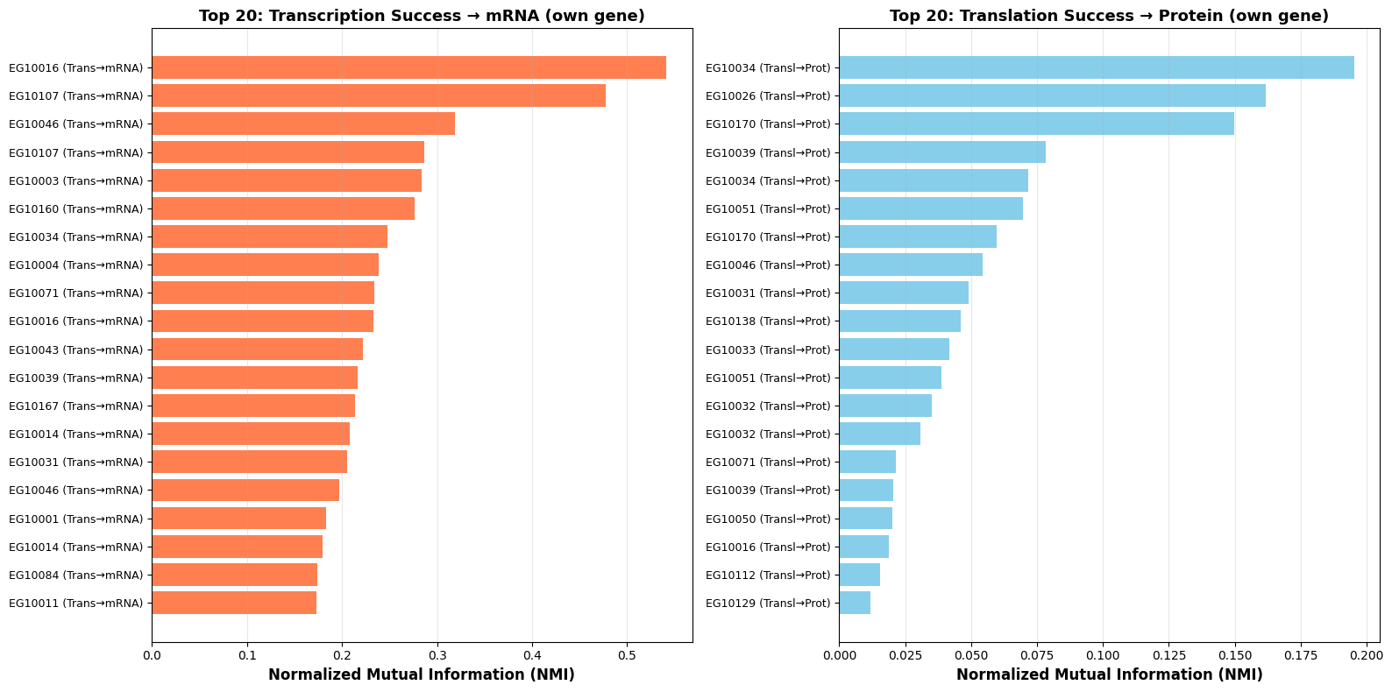
(c) (d)
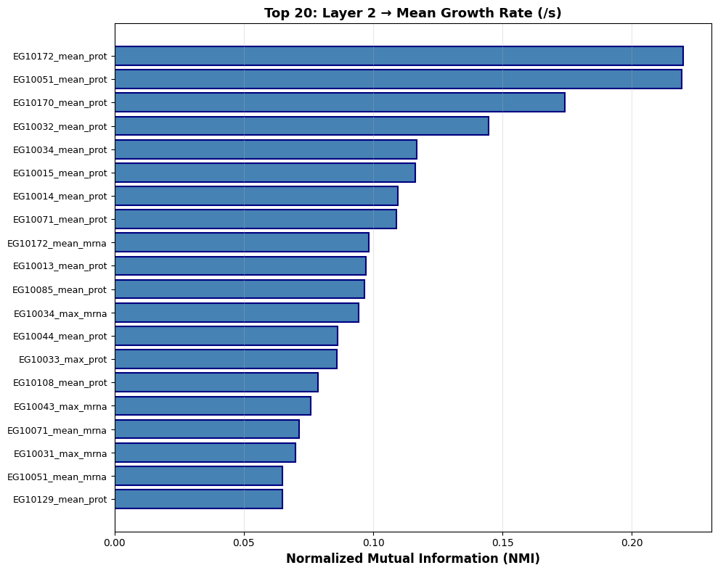
(e)
Figure 5: Top-ranked relationships between conceptual nodes based on mutual information. Graph (a) and (b) show relationships between the input layer and hidden layer 1, corresponding to transcription success and translation success respectively. Graph (c) and (d) represent relationships between hidden layer 1 and hidden layer 2, corresponding to transcription and translation processes. Graph (e) shows the relationship between hidden layer 2 and the output layer, where transcription and translation products from the 40 studied genes are included.

Colony Simulation Using vEcoli
A trial colony simulation was conducted using vEcoli, where one random seed and three generations were considered. One technical limitation was identified: the model does not currently provide continuous tracking of individual cell dynamics within the colony. Instead, the software captures only a snapshot of the system at a pre-specified simulation time. As a result, the selected time point may not correspond exactly to a specific stage of the cell division cycle.
A simulation time of 6000 s from the start of the simulation was selected based on the public vEcoli tutorial. The simulation was performed under the baseline media condition with the standard colony configuration, in which antibiotic responses were not included. The resulting snapshot successfully captured the third generation of colony growth, as indicated by the presence of four cells derived from the original single cell.
Cellular and environmental variables from the colony snapshot were subsequently extracted and visualised (Figures 6 and 7) to explore the capacity of vEcoli to generate spatially resolved cellular and intercellular interaction data.
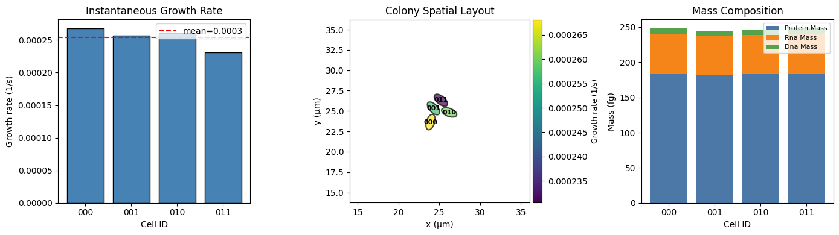
Figure 6: Growth-related data with spatial information for the simulated cells (labelled as 000, 001, 011, and 010, where “1” indicates a division event from the mother cell).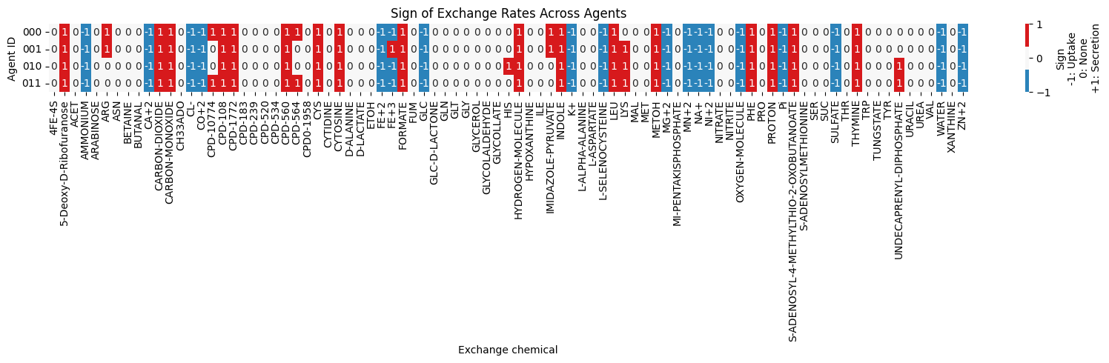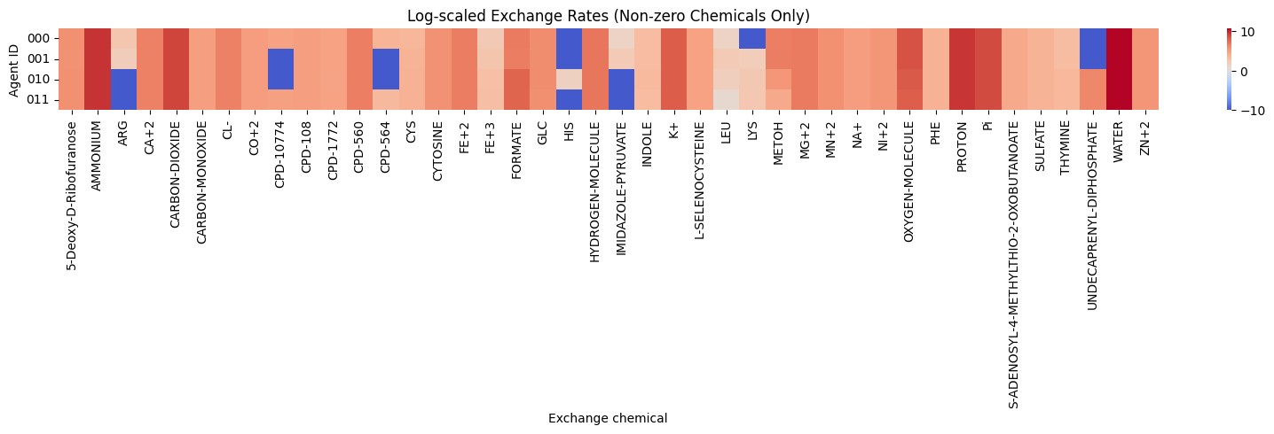
Figure 7: Exchange flux extracted from the vEcoli colony simulation: (a) sign of exchange chemicals; (b) log-scaled non-zero exchange chemicals.
Figure 6 presents growth-related outputs with spatial information for four simulated cells, labelled using a binary lineage encoding in which each digit records a division event at successive generations, allowing individual cells to be traced back to their mother cell. Figure 7 examines the exchange fluxes between cells and their environment: plotting the sign of each flux reveals whether a metabolite is secreted or taken up, while a log-scaled comparison of non-zero fluxes identifies the metabolites most active in intercellular exchange — these represent priority targets for future surrogate model development.

In summary, these exploratory simulations demonstrate that vEcoli can produce the spatially resolved, metabolite-level outputs required to inform and validate future colony-scale surrogate models.

Ongoing Work
An additional 441 single-gene knockout simulations of vEcoli single cells are currently being prepared for data collection, with two random seeds included for each simulation to capture stochastic variation in the model outputs. The gene targets were selected from the functional gene list reported in a previous study (Gherman et al., 2025). These datasets will support the construction of the Phase 1 surrogate model, where surrogate modelling using classical machine learning methods (Linear Regression, Support Vector Regression, as explained in “Methodology” Section) will be implemented to predict cellular growth rate.

Academic Activities and Outputs
During the reporting period, I participated in several academic events related to computational biology and machine learning. At the International Conference on Intelligent Systems for Molecular Biology 2025 / European Conference on Computational Biology 2025 (ISMB/ECCB), I attended tutorials, seminars, and poster sessions related to large cellular models and AI-driven perturbation analysis. I also participated in European Study Group with Industry 187 (ESGI 187), contributing to a collaborative study report (Budd et al., 2026) and authoring the sections on the LoRA encoder matrix method. In addition, I attended the AI, Engineering Biology and Beyond 2026 Conference in Bristol, which provided opportunities to engage with researchers working at the intersection of artificial intelligence and engineering biology.

References
Adamczyk, P.A. and Reed, J.L. (2017). Escherichia coli as a model organism for systems metabolic engineering. Current Opinion in Systems Biology, [online] 6, pp.80–88. doi:https://doi.org/10.1016/j.coisb.2017.11.001.
Angione, C., Silverman, E.S. and Yaneske, E. (2022). Using machine learning as a surrogate model for agent-based simulations. PLoS ONE, 17(2), pp.e0263150–e0263150. doi:https://doi.org/10.1371/journal.pone.0263150.
Budd, J., Joshi, G., Noelle, L., Pickering, M., Setlur, S., Starikova, I., Morehead, C., Xu, N., Zhang, K. and Zyskin, M. (2026). Detecting inappropriate material used to train AI image generation models. doi:https://doi.org/10.33774/miir-2026-rx50v.
Estevez, P.A., Tesmer, M., Perez, C.A. and Zurada, J.M. (2009). Normalized Mutual Information Feature Selection. IEEE Transactions on Neural Networks, 20(2), pp.189–201. doi:https://doi.org/10.1109/tnn.2008.2005601.
Gherman, I.M., Sharma, K., Rees-Garbutt, J., Pang, W., Abdallah, Z.S., Gorochowski, T.E., Grierson, C.S. and Marucci, L. (2025). Accelerated design of Escherichia coli reduced genomes using a whole-cell model and machine learning. Cell Systems, [online] 16(10), p.101392. doi:https://doi.org/10.1016/j.cels.2025.101392.
Großkopf, T., Consuegra, J., Joël Gaffé, Willison, J.C., Lenski, R.E., Soyer, O.S. and Schneider, D. (2016). Metabolic modelling in a dynamic evolutionary framework predicts adaptive diversification of bacteria in a long-term evolution experiment. BMC Evolutionary Biology, 16(1). doi:https://doi.org/10.1186/s12862-016-0733-x.
Hellweger, F.L., Clegg, R.M., Clark, J.H., Plugge, C.M. and Kreft, J.-U. (2016). Advancing microbial sciences by individual-based modelling. Nat Rev Microbiol, 14(7), pp.461–471. doi:https://doi.org/10.1038/nrmicro.2016.62.
Jose Nathan Kutz, Brunton, S.L., Brunton, B.W. and Proctor, J.L. (2017). Dynamic mode decomposition : data-driven modeling of complex systems. Philadelphia: Society For Industrial And Applied Mathematics.
Ma, J., Yu, M.K., Fong, S., Ono, K., Sage, E., Demchak, B., Sharan, R. and Ideker, T. (2018). Using deep learning to model the hierarchical structure and function of a cell. Nature Methods, [online] 15(4), pp.290–298. doi:https://doi.org/10.1038/nmeth.4627.
Mackay, D.J.C. (2003). Information theory, inference, and learning algorithms. Cambridge: Cambridge University Press.
Macklin, D.N., Ahn-Horst, T.A., Choi, H., Ruggero, N.A., Carrera, J., Mason, J.C., Sun, G., Agmon, E., DeFelice, M.M., Maayan, I., Lane, K., Spangler, R.K., Gillies, T.E., Paull, M.L., Akhter, S., Bray, S.R., Weaver, D.S., Keseler, I.M., Karp, P.D. and Morrison, J.H. (2020). Simultaneous cross-evaluation of heterogeneous E. coli datasets via mechanistic simulation. Science, 369(6502), p.eaav3751. doi:https://doi.org/10.1126/science.aav3751.
Meirer, J., Wittwer, L.D., Revol, V. and Heinemann, T. (2024). DeepBINN: A tailored biologically-informed neural network for robust biomarker identification. 2024 11th IEEE Swiss Conference on Data Science (SDS), pp.246–249. doi:https://doi.org/10.1109/sds60720.2024.00044.
NumFOCUS, Inc. (2026). pandas.qcut — pandas 2.2.2 documentation. [online] pandas.pydata.org. Available at: https://pandas.pydata.org/pandas-docs/stable/reference/api/pandas.qcut.html.
Pruett, W.A. and Hester, R.L. (2016). The Creation of Surrogate Models for Fast Estimation of Complex Model Outcomes. PLOS ONE, 11(6), pp.e0156574–e0156574. doi:https://doi.org/10.1371/journal.pone.0156574.
Selby, D.A., Sprang, M., Ewald, J. and Vollmer, S.J. (2025). Beyond the black box with biologically informed neural networks. Nature Reviews Genetics. doi:https://doi.org/10.1038/s41576-025-00826-1.
Skalnik, C.J., Cheah, S.Y., Yang, M.Y., Wolff, M.B., Spangler, R.K., Talman, L., Morrison, J.H., Peirce, S.M., Eran Agmon and Covert, M.W. (2023). Whole-cell modeling of E. coli colonies enables quantification of single-cell heterogeneity in antibiotic responses. PLOS Computational Biology, 19(6), pp.e1011232–e1011232. doi:https://doi.org/10.1371/journal.pcbi.1011232.
Tack, I., Philippe Nimmegeers, Simen Akkermans, Hashem, I. and Jan Van Impe (2017). Simulation of Escherichia coli Dynamics in Biofilms and Submerged Colonies with an Individual-Based Model Including Metabolic Network Information. Frontiers in Microbiology, 8. doi:https://doi.org/10.3389/fmicb.2017.02509.
Zomorrodi, A.R. and Segrè, D. (2017). Genome-driven evolutionary game theory helps understand the rise of metabolic interdependencies in microbial communities. Nature Communications, 8(1). doi:https://doi.org/10.1038/s41467-017-01407-5.

Appendix 1 – Implemented Gene Knockout Algorithm

Algorithm 1: Gene Knockout Variant
(Parameter Read from Simulation Configuration)

Input: Simulation data object sim_data, parameter dictionary params containing genes_to_knockout
Output: Modified sim_data with synthesis probabilities set to zero for all transcription units (TUs) containing the target genes

- If genetic_perturbations attribute does not exist on sim_data, initialise it as an empty dictionary
- For each gene_id in params[genes_to_knockout]:
  - For each cistron in the transcription cistron data:
    - If cistron[gene_id] matches gene_id:
      - Retrieve cistron_id from the matched cistron
      - Query all transcription unit indices associated with cistron_id
      - For each transcription unit index ridx:
        - Retrieve the RNA identifier rna_id from the transcription unit data
        - Set sim_data.genetic_perturbations[rna_id] ← 0.0
      - Break — cistron found, proceed to next gene_id
- Return modified sim_data
Note: A single gene may belong to a polycistronic operon. Setting the synthesis probability of a transcription unit to zero therefore silences all genes encoded within that operon, not only the intended target. This behaviour reflects the operon structure of the E. coli genome and should be considered when interpreting knockout simulation results.

Appendix 2 - Details of Five Media Conditions

Table 1. Media conditions used in simulation experiments.
condition | nutrients | doubling time (min) | base media | base media volume (L) | added media | added media volume (L) | ingredients
baseline | minimal | 44.0 | MIX0-57 | 1.0 |  | 0.0 | []
with amino-acid | minimal_plus_amino_acids | 25.0 | MIX0-57 | 0.8 | 5X_supplement_EZ | 0.2 | []
acetate | minimal_acetate | 136.0 | MIX0-58 | 1.0 |  | 0.0 | []
succinate | minimal_succinate | 82.0 | MIX0-844 | 1.0 |  | 0.0 | []
no oxygen | minimal_minus_oxygen | 100.0 | MIX0-57 | 1.0 |  | 0.0 | ["OXYGEN-MOLECULE", "4FE-4S"]

Table 2. Definitions of columns in Table 1.
Column | Explanation
condition | Report label of the experimental condition.
nutrients | Media recipe identifier linked to each condition in condition_defs.tsv.
doubling time (min) | Expected doubling time under the condition, in minutes.
base media | ID of the linked base medium file in flat/condition/media.
base media volume (L) | Volume (L) of the base medium used in the recipe.
added media | ID of any additional medium mixed with the base medium.
added media volume (L) | Volume (L) of the added medium used in the recipe.
ingredients | Explicit ingredient modifications for the condition recipe.

Table 3. Composition of base medium MIX0-57.
molecule id | concentration (mmol / L)
NA+ | 135.15
Pi | 63.851
CL- | 55.389
AMMONIUM | 30.272
K+ | 21.883
SULFATE | 15.077
MG+2 | 2.1
CA+2 | 0.09
FE+3 | 0.0031
WATER | inf
GLC | 11.101
CARBON-DIOXIDE | inf
OXYGEN-MOLECULE | inf
CO+2 | inf
FE+2 | inf
MN+2 | inf
NI+2 | inf
ZN+2 | inf
L-SELENOCYSTEINE | inf

Table 4. Composition of base medium MIX0-58
molecule id | concentration
NA+ | 135.15
Pi | 63.851
CL- | 55.389
AMMONIUM | 30.272
K+ | 21.883
SULFATE | 15.077
MG+2 | 2.1
CA+2 | 0.09
FE+3 | 0.0031
WATER | inf
ACET | 67.746
CARBON-DIOXIDE | inf
OXYGEN-MOLECULE | inf
CO+2 | inf
FE+2 | inf
MN+2 | inf
NI+2 | inf
ZN+2 | inf
L-SELENOCYSTEINE | inf

Table 5. Composition of base medium MIX0-844
molecule id | concentration (mmol / L)
NA+ | 135.15
Pi | 63.851
CL- | 55.389
AMMONIUM | 30.272
K+ | 21.883
SULFATE | 15.077
MG+2 | 2.1
CA+2 | 0.09
FE+3 | 0.0031
WATER | inf
SUC | 17.0
CARBON-DIOXIDE | inf
OXYGEN-MOLECULE | inf
CO+2 | inf
FE+2 | inf
MN+2 | inf
NI+2 | inf
ZN+2 | inf
L-SELENOCYSTEINE | inf

Glossary
Agent-based model (ABM)
A simulation framework in which individual entities (cells) act independently according to defined rules.
Artificial neural network (ANN)
A machine learning model composed of interconnected layers of artificial neurons used to learn complex nonlinear relationships between inputs and outputs.
Bio-informed neural network (BINN)
A neural network architecture whose hidden layers correspond to biologically meaningful intermediate processes rather than abstract latent variables.
Cistron
A DNA sequence encoding a single polypeptide within a transcription unit.
Dynamic Mode Decomposition (DMD)
A data-driven method for modelling dynamical systems by decomposing time-series data into spatial–temporal modes and estimating linear dynamics between system states.
Exchange flux
The rate at which metabolites are transported between a cell and its external environment. In the vEcoli simulation outputs used in this study, exchange flux is recorded in units of molecule counts per second (count s⁻¹).
Genome-scale metabolic model (GSMM)
A mathematical representation of the metabolic network of an organism based on genomic annotation and biochemical knowledge.
High-performance computing (HPC)
The use of parallel computing resources, such as clusters or supercomputers, to perform computationally intensive simulations and analyses.
Multi-task learning
A machine learning approach in which multiple related outputs are predicted simultaneously using a shared representation to improve generalisation performance.
Mutual information (MI)
An information-theoretic measure of statistical dependence between two variables.
Normalised mutual information (NMI)
A scaled version of mutual information bounded between 0 and 1, allowing comparison across datasets with different entropy levels.
Operon
A group of genes transcribed together under the control of a single promoter and regulated as a single transcriptional unit.
Stochastic simulation
A simulation approach in which randomness is explicitly incorporated to represent probabilistic biological processes such as gene expression and molecular interactions.
Support vector regression (SVR)
A supervised machine learning method derived from support vector machines that performs regression by fitting a function within a specified error tolerance.
Surrogate model
A computationally efficient approximation of a more complex and computationally expensive simulation model.
Transcription unit (TU)
A contiguous segment of DNA that is transcribed into a single RNA molecule, potentially containing multiple genes in prokaryotic operons.
vEcoli
A colony-level extension of the wcEcoli whole-cell model that enables simulation of interacting cells within a shared spatial environment.
Whole-cell model (WCM)
A comprehensive computational model that integrates metabolic, regulatory, and signalling processes to simulate the complete life cycle of a cell.
wcEcoli
The first comprehensive whole-cell model of Escherichia coli, developed by the Covert Lab, integrating multiple cellular processes into a single simulation framework.

